🗺️ Overview



REMEDIATION REPORT
for
MEGAQUAGGA PUBLISHING
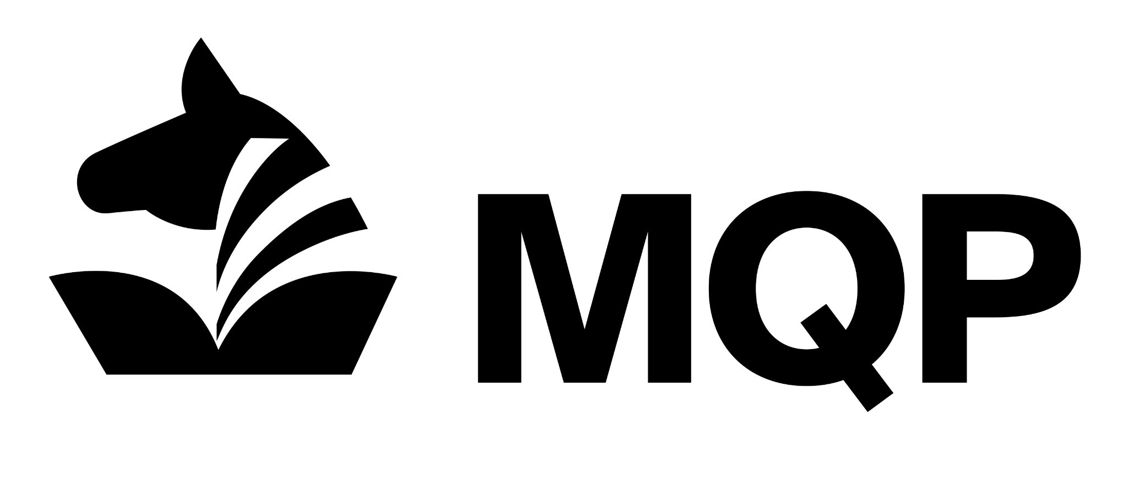
Version 1.0 (July 6th, 2025)
Prepared by Ryan Tomek | Presented to MEGAQUAGGA PUBLISHING

DISCLAIMER: This document contains proprietary and confidential information. 0x2A SECURITY guarantees the confidentiality of the information and any other material that has or will be disclosed during the performance of this service. A mutual non-disclosure agreement of confidential information is assumed between 0x2A SECURITY and MEGAQUAGGA PUBLISHING, limiting the use of confidential information exclusively for purposes associated with properly delivering this service.
Disclaimer: These documents contain confidential information regarding Ox2A Security.
Here within contains the agreement between Megaquagga j& Ox2A.

EXECUTIVE SUMMARY
This document contains the findings & recommendations for the vulnerability scannings of the domain www.megaquagga.local.. Scans like WPscan are used to gather information about the target. Then we used Metasploit to exploit the vulnerabilities. This report will help improve all of your IT systems security via the recommendations hereafter.

The recommendations for the vulnerabilities are, performing updates for plugins & WordPress. Staying current with updates will help your network avoid the newest bug. We suggest updating weekly to monthly.

We would enable HTTPS connection. By switching from HTTP to HTTPS we are moving our internet traffic from plain text to encrypted. Everyone who's anyone is using HTTPS because it is faster & safer than HTTP. Receiving a fingerprint from a CA (Certificate Authority) builds credibility & processes better SEO (Search Engine Optimization) results.

We would configure & set up WAF (Web Application Firewall). By applying a WAF, application level security on layer 7 would become hardened. It is a way to prevent malicious code from entering your system/program.

We would recommend utilizing a reverse proxy. To use a reverse proxy is to add a layer of security where most are not well versed. Reverse proxies are a leading method for hiding an origin IP from investigators. Instead of entering your network, the attacker is cut off at the reverse proxy server. To redirect traffic through a proxy server is to examine/filter all the traffic before it enters your host server.

By introducing a reverse proxy you can hide the identity of the origin server, the wordpress server. In doing so you prevent it from direct attacks from the public internet. Other benefits include load balancing & performance optimization.

Implementing SSL Offloading provides privacy & protection by utilizing end-to-end encryption.

🦾 Actions Taken

ACTIONS TAKEN
This section outlines the actions taken on which assets to remediate which vulnerabilities.

Vulnerability | Remediation Solution
WordPress is vulnerable to web application attacks | WAF & Reverse Proxy
Unencrypted web traffic | SSL offloading

Remediation Solution #1: Apache Reverse Proxy

Action: Deploy Apache reverse proxy with Modsecurity
Asset affected: Apache reverse proxy server
Fix Applied: Install & configure reverse proxy server with Modsecurity
Discovery: During vulnerability scan WP server was identified as being exposed to Web Application Attack, such as SQL Injection & Cross Site Scripting. These vulnerabilities are a result of lack of filtering of incoming traffic.
Description: To fix these vulnerabilities we deployed a WAF & set rules for its function. This was done by configuring the reverse proxy to filter traffic through the proxy server first before reaching the WordPress server. We configured the reverse proxy with the OWASP core rules set.
Outcome: This action will reduce the attack surface of the WP server by filtering traffic through the reverse proxy before it’s able to enter the WP server.

Remediation Solution #2: SSL Offload

Action: SSL Offloading
Asset Affected: Apache reverse proxy server
Fix Applied: We changed the SSL decryption to reverse proxy.
Discovery: WordPress server was handling both application load & encryption tasks which led to unnecessary resource usage & performance degradation.
Description: To optimize server performance, we implemented a SSL Offloading at the Apache reverse proxy which led to the reverse proxy server responsible for decrypting the SSL before passing to the WordPress.
Outcome: The WordPress server load is reduced which leads to increased performance & faster responses.

Remediation Solution #3: pfSense Firewall

Action: Update pfSense firewall & NAT rules
Asset: pfSense Firewall
Fix Applied: We changed the rules & updated the NAT rules.
Discovery: After enabling SSL encryption on the reverse proxy we discovered that the https traffic was not routed through the pfSense firewall.
Description: To resolve the above issue, we updated the NAT rules to ensure that the https traffic is routed to the proxy server.
Outcome: The HTTPS traffic is now properly routed to the WAN users to the reverse proxy which allows users to access WordPress securely.

☑️ Evidence of Remediation

EVIDENCE OF REMEDIATION
This section documents evidence of the remediations being implemented. This evidence may take the form of details from packet captures (for example, alterations in traffic flow or packet headers), ModSecurity logs appearing in the Graylog SIEM, or output from command-line tools. For each remediation, we provide evidence of the original state as well as the current altered state.

Reverse proxy
These are alterations to MegaQuagga’s environment associated with implementing the reverse proxy server responsible for implementing our two remediations (WAF & SSL offloading).

Item | Original Vulnerable State | Current Remediated State
/etc/modsecurity/modsecurity.conf | SecRuleEngine DetectionOnly | SecRuleEngine On
WAF | Traffic was not being proxied between the client & the proxy server (pfSense LAN 1) | Traffic is now being proxied between the client & the proxy server (pfSense LAN 2)

Web Application Firewall (WAF)
These are alterations to MegaQuagga’s environment associated with implementing the WAF remediation.

Item | Original Vulnerable State | Current Remediated State
Changed NAT rule WAN | Destination IP 192.168.100.2 port 80 to NAT IP 10.20.30.130 port 80 | Destination IP 192.168.100.2 port 80 to NAT IP 10.20.30.220 port 80
New firewall WAN rule |  | Changed HTTPS port 443 to 10.20.30.220
New NAT rule |  | Destination IP 192.168.100.2 port 443 to NAT IP 10.20.30.220 port 443

SSL Offloading
These are alterations to MegaQuagga’s environment associated with implementing the WAF remediation.

Item | Original Vulnerable State | Current Remediated State
000-default.conf |  | RewriteEngine On  RewriteRule ^/(.*) https://%{HTTP_HOST}/$1 [R=301,L]
000-default-ssl.conf |  | <VirtualHost *:80>  # The ServerName directive sets the request scheme, hostname and port that  # the server uses to identify itself. This is used when creating  # redirection URLs. In the context of virtual hosts, the ServerName  # specifies what hostname must appear in the request's Host: header to  # match this virtual host. For the default virtual host (this file) this  # value is not decisive as it is used as a last resort host regardless.  # However, you must set it for any further virtual host explicitly.  #ServerName www.example.com  RewriteEngine On  RewriteRule ^/(.*) https://%{HTTP_HOST}/$1 [R=301,L]  #ServerAdmin webmaster@localhost  #DocumentRoot /var/www/html  ProxyPreserveHost On  ProxyPass / http://10.20.30.130/  ProxyPassReverse / http://10.20.30.130/  # Available loglevels: trace8, ..., trace1, debug, info, notice, warn,  # error, crit, alert, emerg.  # It is also possible to configure the loglevel for particular  # modules, e.g.  #LogLevel info ssl:warn  #ErrorLog ${APACHE_LOG_DIR}/error.log  #CustomLog ${APACHE_LOG_DIR}/access.log combined  CustomLog "||/usr/bin/logger -t apache -i -p local5.notice" combined  # For most configuration files from conf-available/, which are  # enabled or disabled at a global level, it is possible to  # include a line for only one particular virtual host. For example the  # following line enables the CGI configuration for this host only  # after it has been globally disabled with "a2disconf".  #Include conf-available/serve-cgi-bin.conf  Header set X-Reverse-Proxy "Active"  </VirtualHost>

🩺 Recommendations

RECOMMENDATIONS
This section outlines recommendations for continued monitoring and next steps for future remediations to further strengthen MegaQuagga’s security posture.

Recommendation #1: Vulnerability & Patch management
- Conduct vulnerability scans regularly
- Update systems to properly patch vulnerabilities
- Test updates

Recommendation #2: Intrusion Prevention System (IPS)
- Deploy/install an IPS
- Employs real time threat protection
- Sends alerts when threats are detected
- Allows for virtual patching which provides additional time to deploy patches

Recommendation #3: Log Management
- Install SIEM
- SIEM to alert when IPS is triggered
- SIEM centralizes all alert logs
- Prioritizes & archives logs

📍 Conclusion

CONCLUSION

In conclusion, we upgraded from HTTP to HTTPS. The web traffic is no longer being routed in plain text.
We implemented a Proxy & WAF. We also applied SSL Offloading.

We recommend implementing patch & vulnerability management, Intrusion Prevention Systems & Log Management.

